

**FPT ACADEMY INTERNATIONAL**

**FPT – APTECH COMPUTER EDUCATION**

**USER GUIDE FOR RHYTHM HOUSE WEBSITE**

**I. System Requirement**

|  |  |  |
| --- | --- | --- |
| **No** | **Software** | **Description** |
| **1** | **Operating system** | **Windows 7 or higher** |
| **2** | **Hardware** | **Intel Pentium 4 processor or higher**  **512 Megabytes of RAM or higher** |
| **3** | **Software** | **Visual Studio Code, Dreamweaver** |
| **4** | **Web browser** | **Internet Explorer 11 , Chrome, Firefox, Safari** |

1. **Introduction and website installation**

- This document is created to guide users use the website – Rhythm House effectively. It is advisable that users should read this document before starting to use this website in reality.

- To run *Rhythm House* website, users need to do the following steps:

* + - 1. Download the file rar *eProject – Rhythm House by Group 5 (FPT Aptech HCM)* via this link:
      2. Extract the file rar: *eProject – Rhythm House by Group 5 (FPT Aptech HCM)*

1. Open the folder *eProject*
2. Open *Index.html* file to start the website. Look at figure 1 for illustration

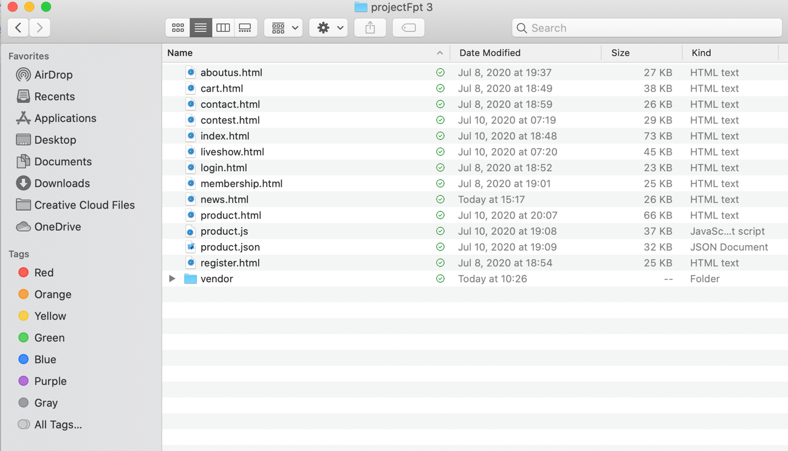

*Figure 1*

1. If done successfully, users will see the Homepage like figure 2 below

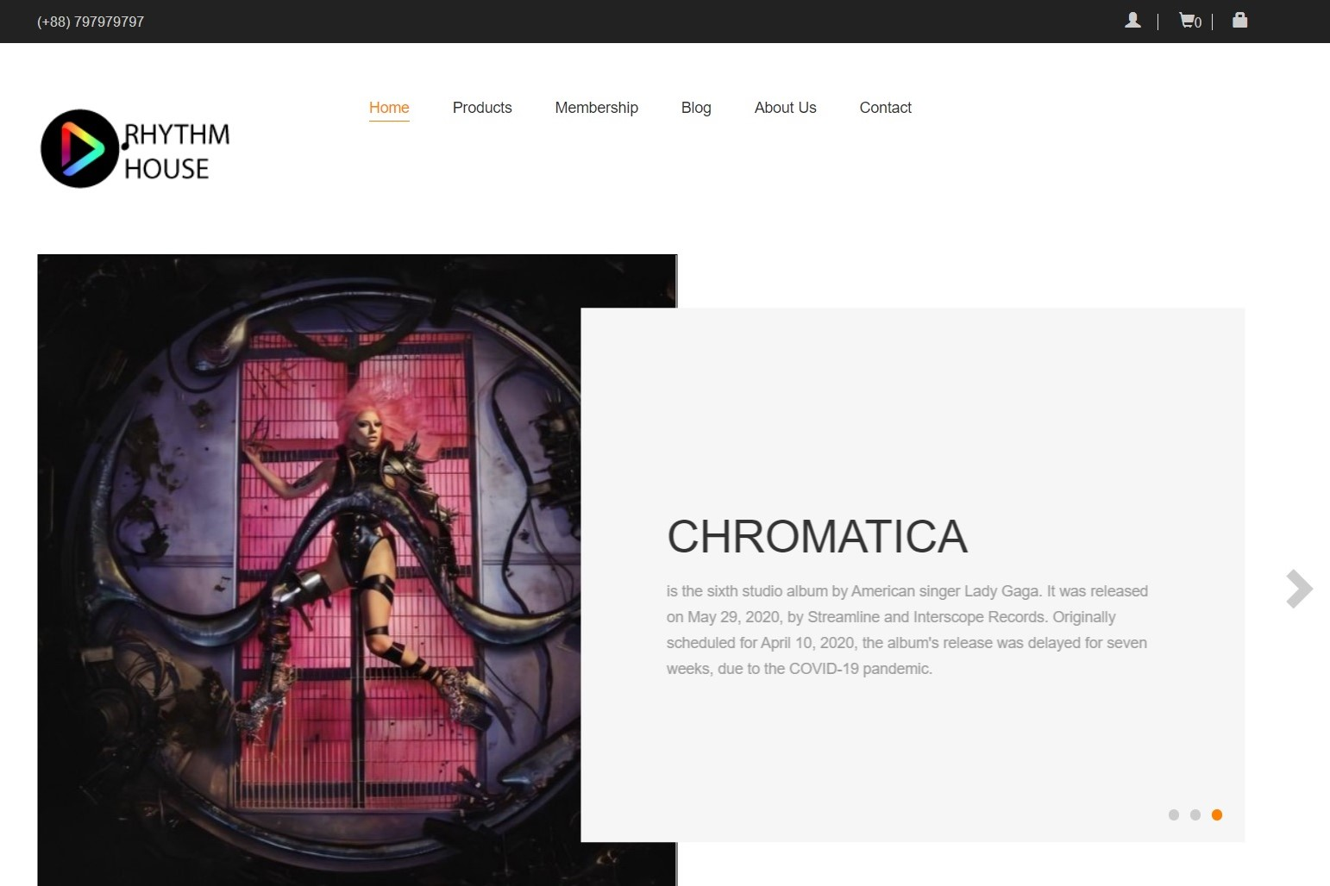

*Figure 2*

1. **Product**

- This webpage allows users to find the information for the products they’re looking for. To get the details of a particular item, users need to click on the button “Click for more details”, which will automatically open the information page for that item. For example, figure 3 illustrates how to get detailed information for single product.

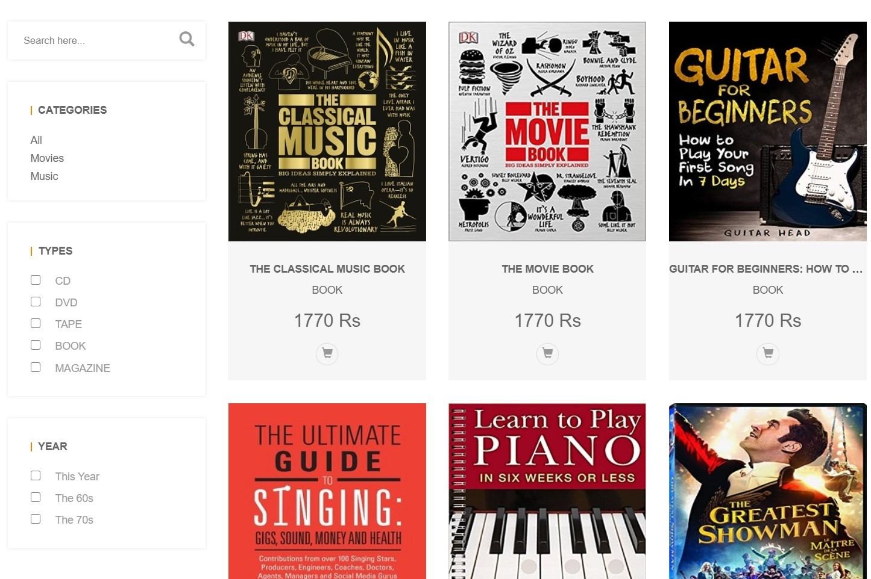

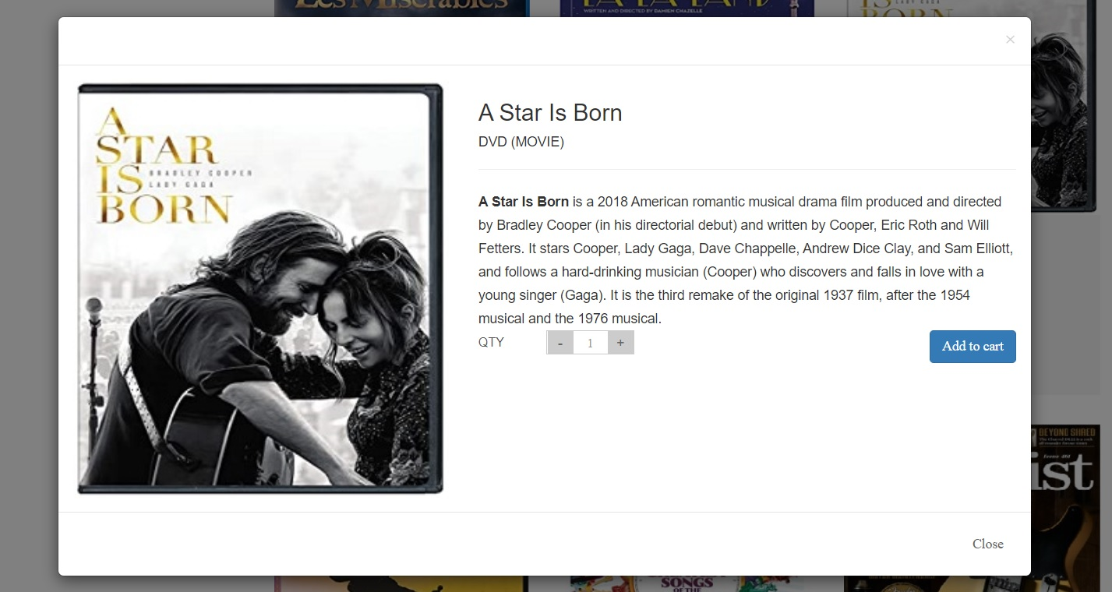

*Figure 3*

- To make it easier for users to find the product as fast as possible, we created to filter option and search bar.

+ As for search bar: To use this function, users need to type the name of a particular product and then press enter. To reset, they need to erase what they typed and press enter.

1. **Membership**

- This webpage allows users to see the membership information of Rhythm House, as well as some perks to be a VIP member.

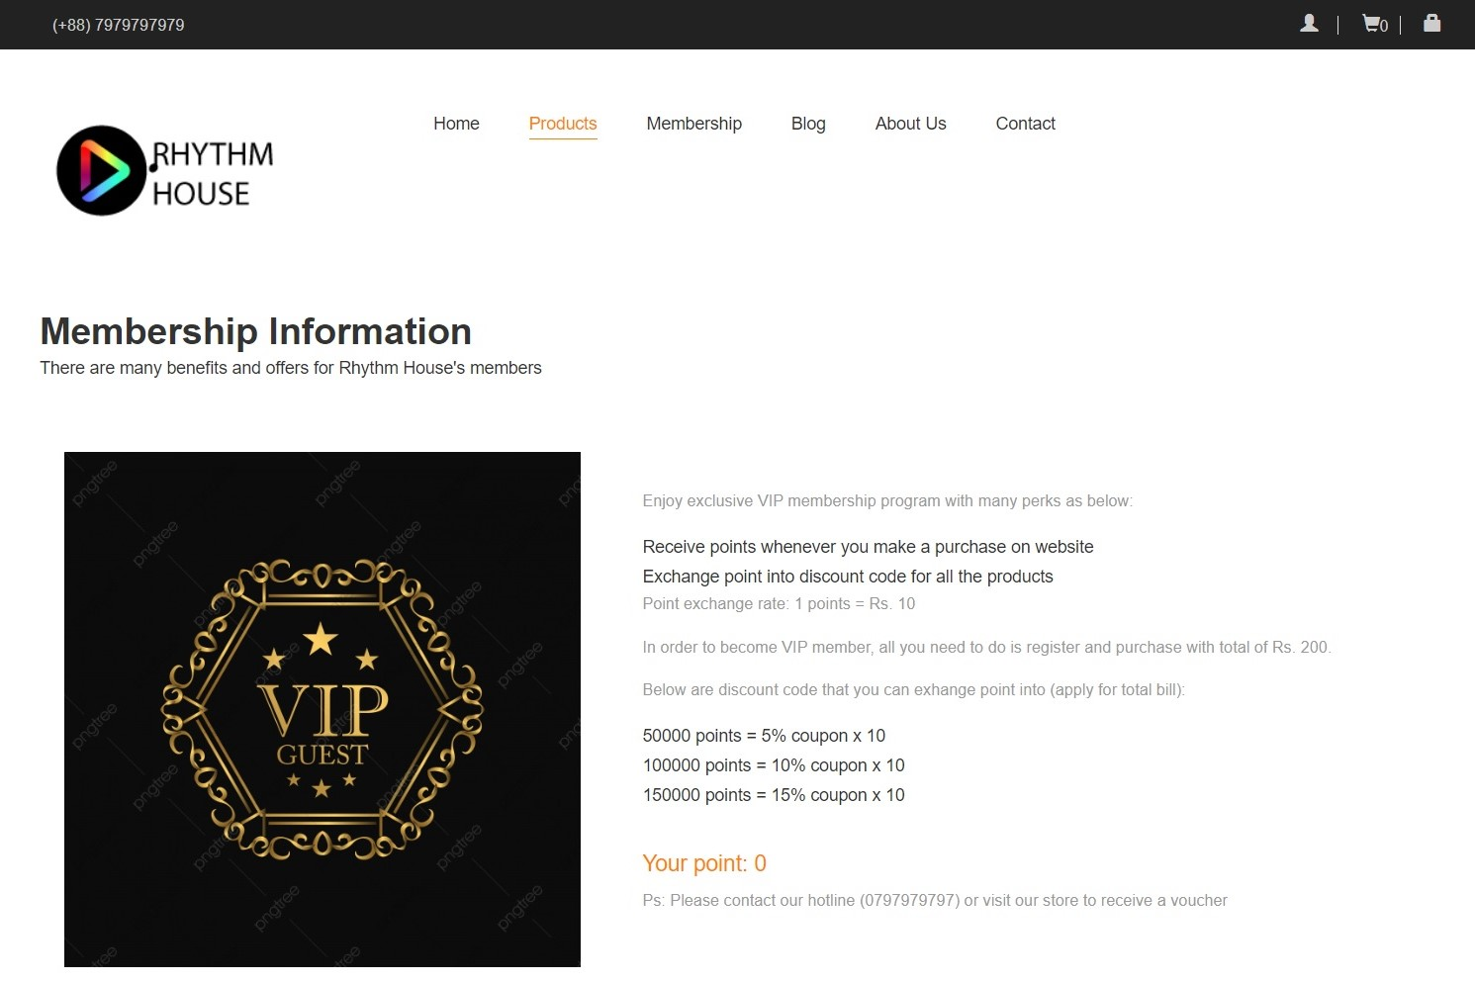

*Figure 4*

1. **Blog**

The blog page displays following information:

* Live show (figure 5).
* Music contest (figure 6).
* Events (figure 7).

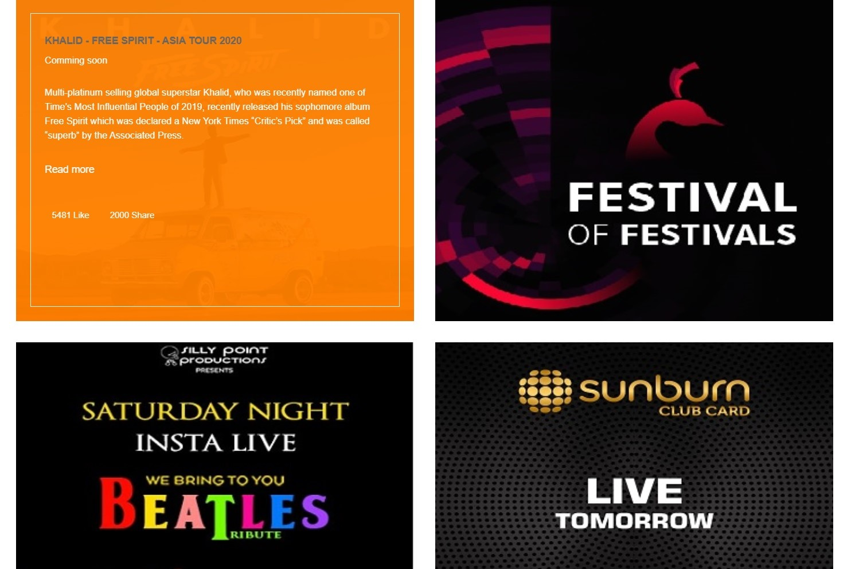

*Figure 5*

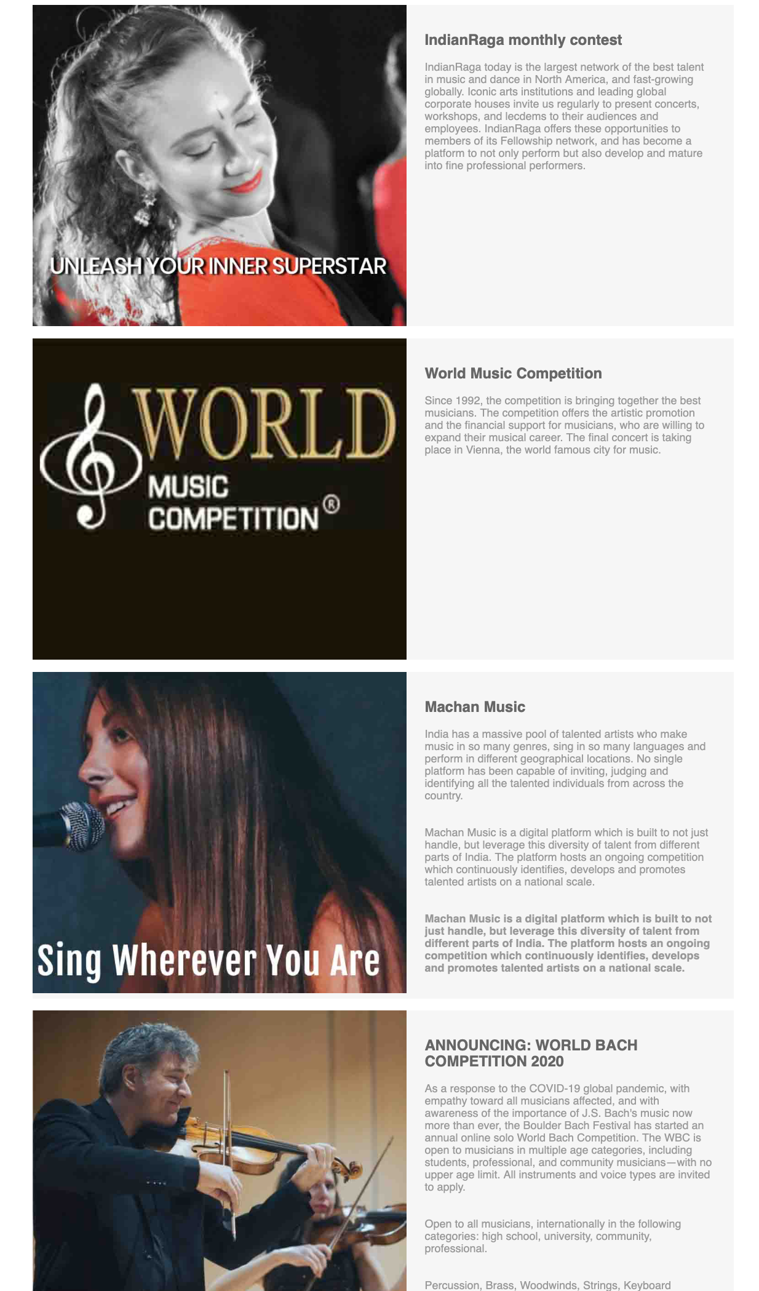

*Figure 6*

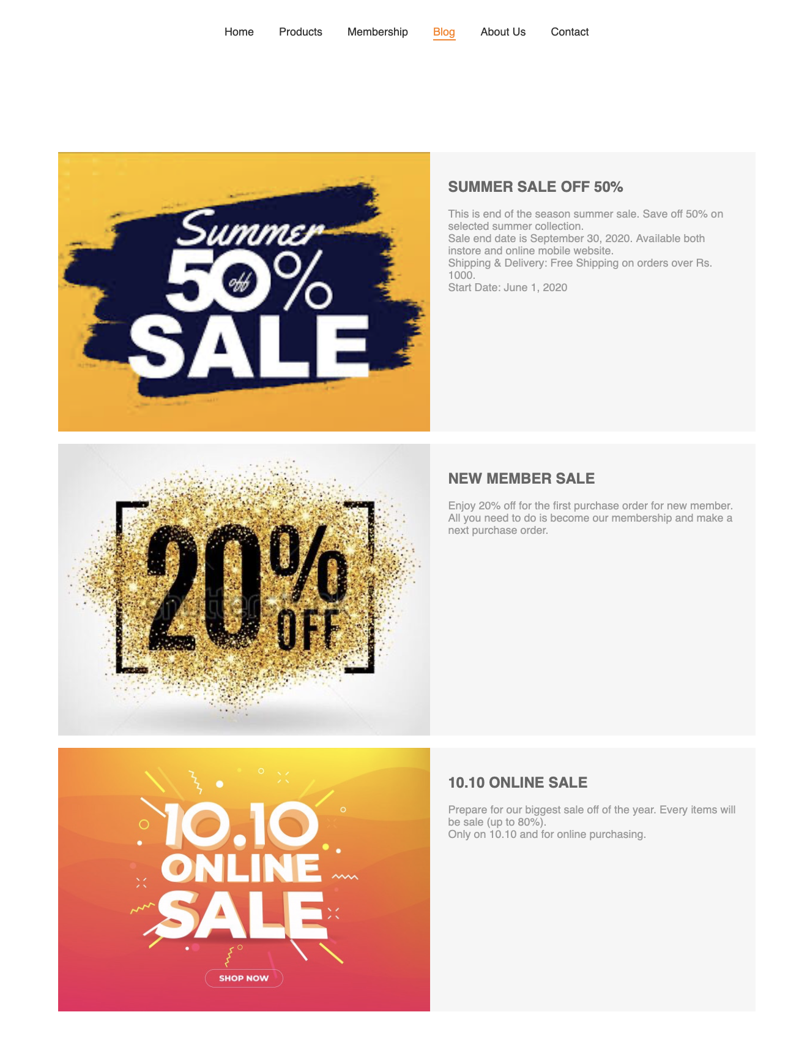

*Figure 7*

1. **About us**

- This page displays information about the history of Rhythm House, our service that we provide and our team member.

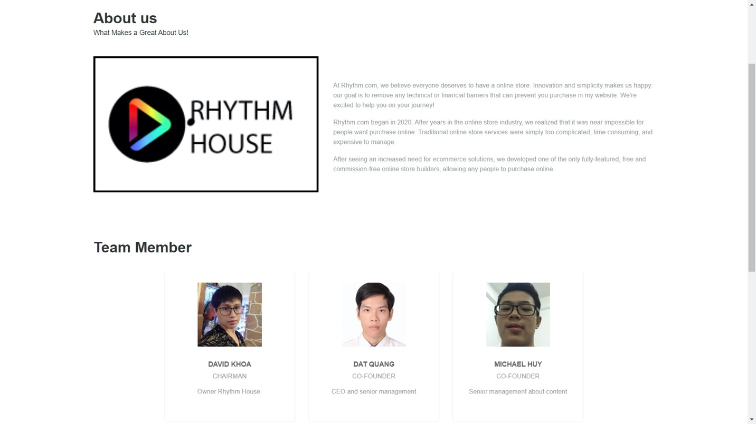

*Figure 8*

1. **Contact page**

- This page displays contact information: location, telephone number, email and a quick contact form for customer.

*Figure 9*

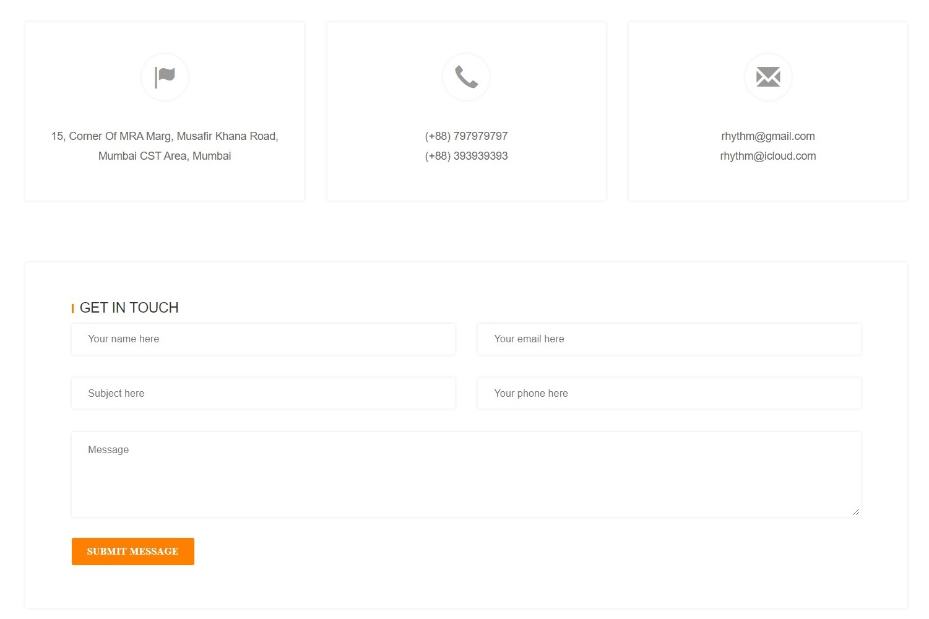

1. **Log in**

* This webpage displays log in form for customer, it will require email address and password.

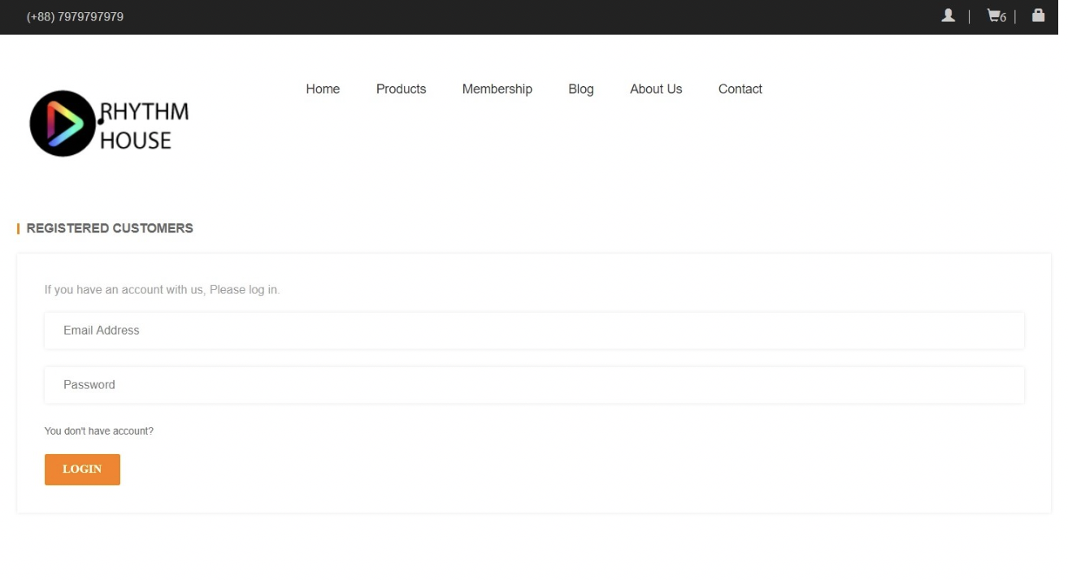

*Figure 10*

1. **Register**

This webpage displays register form allow customer sign up for membership. It will require some information of user such as: first name, last name, phone number, email address and password.

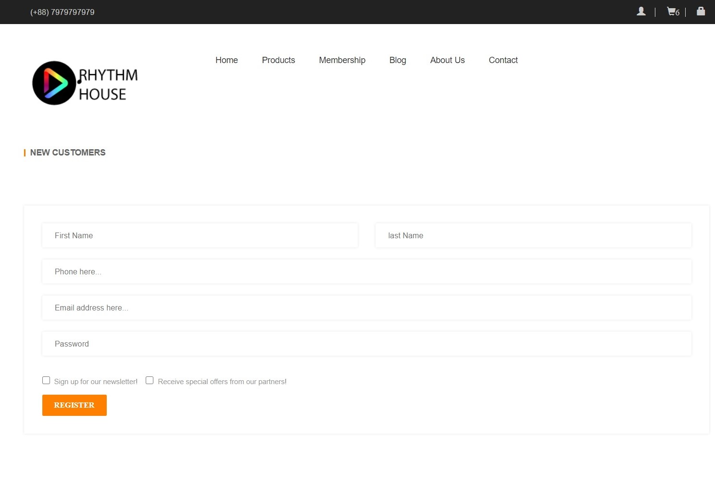

*Figure 11*

1. **Cart**

This webpage displays item that being purchased, quantity and price of each item.

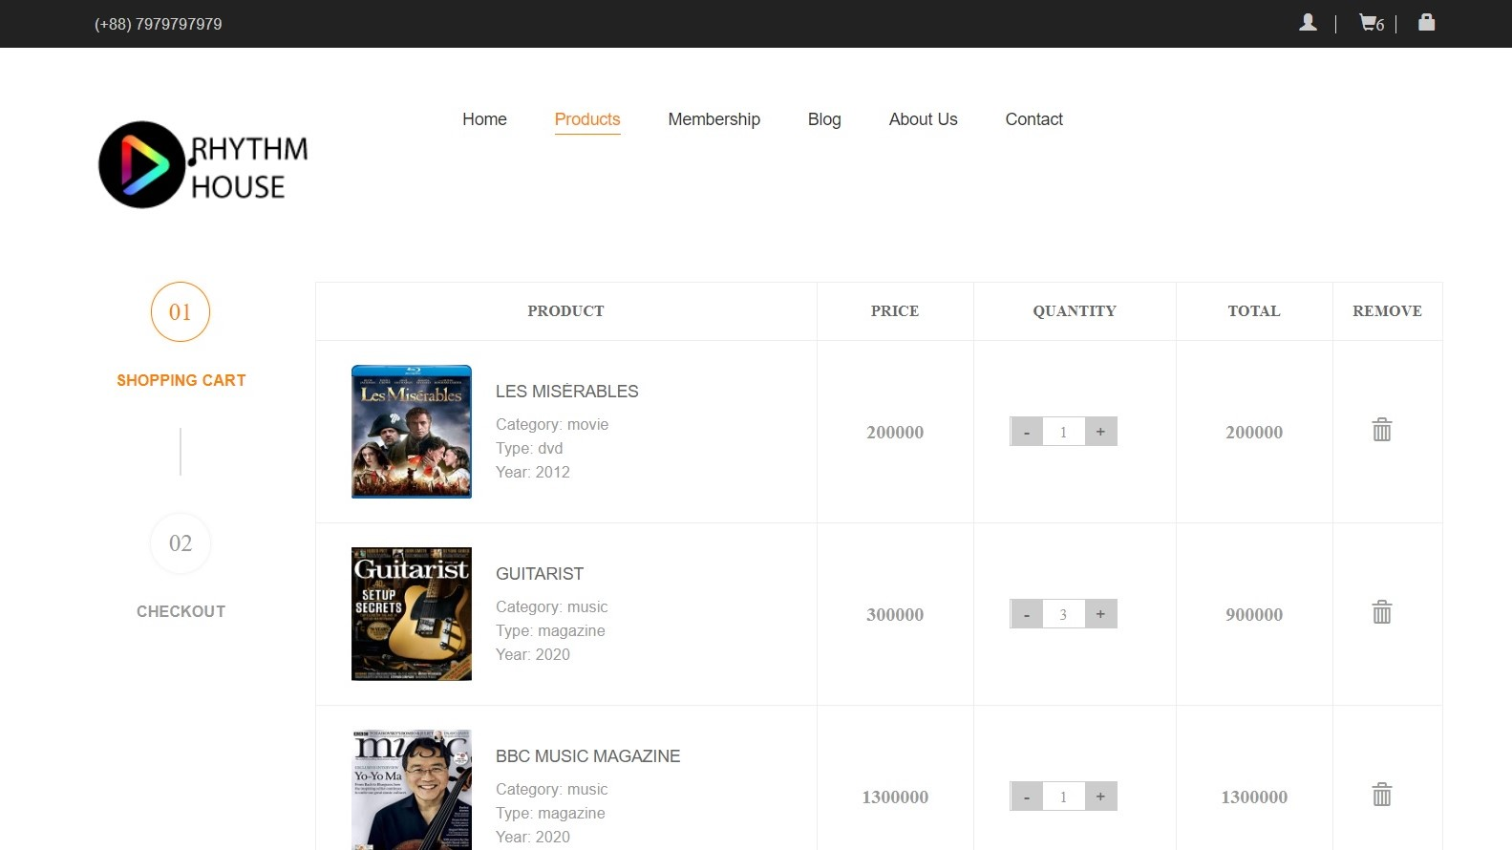

*Figure 12*

1. **Check out**

This webpage displays billing detail and total price of items that we wish to purchase. Upon clicking place order, the purchase order will be placed.

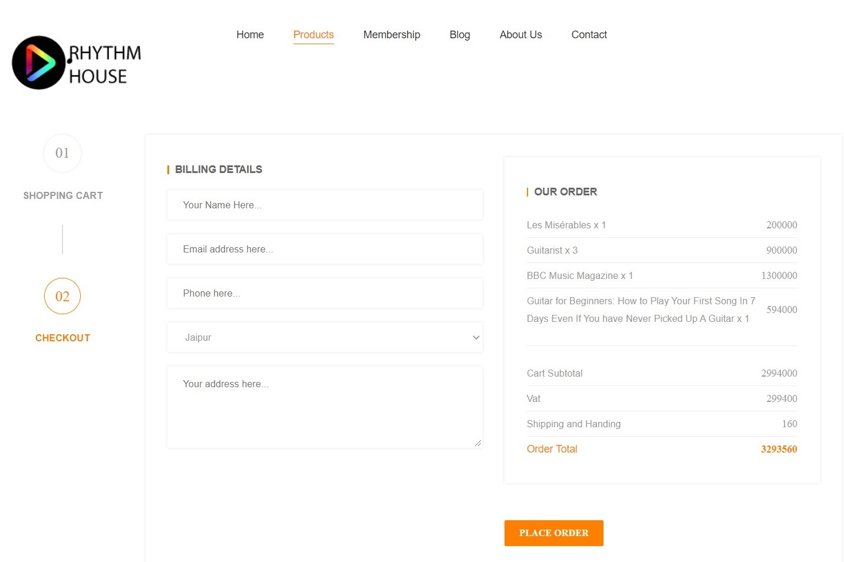

*Figure 13*